Swing is used for GUI ct

**Hierarchy**

Project->Test Suite-> Test case-> Test Step

Test Suite

Test case

Test Step

Example – Customer # 10

<http://www.thomas-bayer.com/sqlrest/CUSTOMER/>

http://www.webservicex.com/globalweather.asmx?wsdl

This gives all the information about customers.

If you have to choose the customer # 10, then you use the resource as 10

<http://www.thomas-bayer.com/sqlrest/CUSTOMER/10>

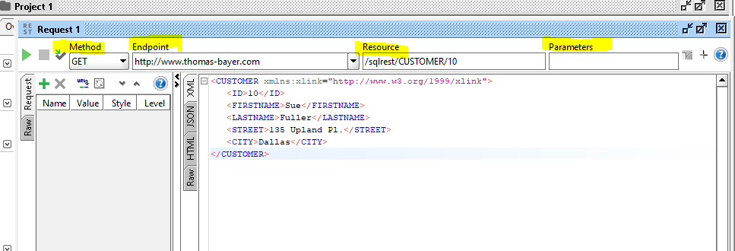

What did I learn?

1. How to create a Soap API Project?
2. How to add WSDL?
3. How to create Project->Test Suite->Testcase-> Test Step
4. How to add Assertions
5. How to run Testcase in parallel and in Sequence
6. How to Create API documentation?

SOAP Services

RESt Services

URI – Uniform Resource identifier

Following is the rest api ( sample)

<https://restcountries.eu/>

All Countries

<https://restcountries.eu/rest/v2/all>

<https://restcountries.eu/rest/v2/name/united>

https://restcountries.eu/rest/v2/name/{name}

How to add Parameters

Example: You use this to search by countryname

https://restcountries.eu/rest/v2/name/united

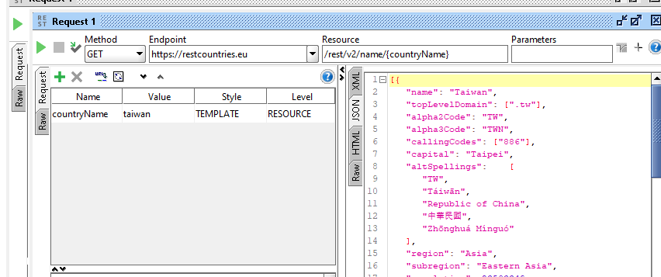

You can add Parameter to Resource

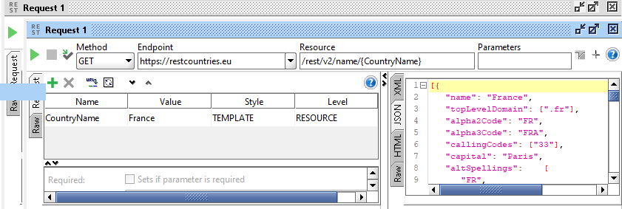

You can parameterize resource as well as Parameters.

https://restcountries.eu/rest/v2/name/{name}?fullText=true

https://restcountries.eu/rest/v2/name/aruba?fullText=true

name – stands for country names

fullText – it is true or false

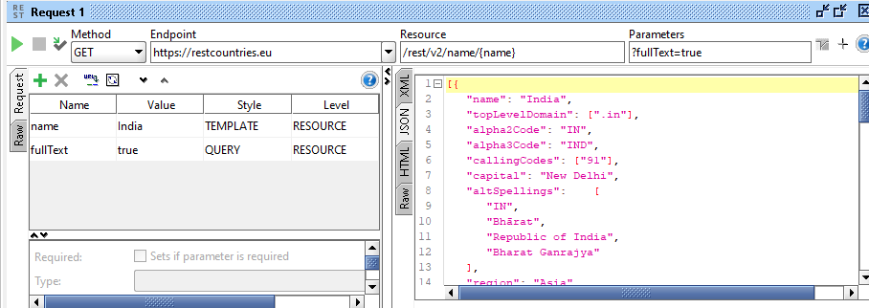

Properties are used to store value

It is considered as variables

To create new Test Suite, right click on the project and select “ Generate Test Suite” – you can then customize to what you want?

* You can add properties at the Project or Test Suite or Test case or Test Step level and then cascade it on the actual request

Properties can be accessed at following levels:

Project - ${[#Project](https://www.youtube.com/results?search_query=%23Project)[#PropertyName](https://www.youtube.com/results?search_query=%23PropertyName)}

TestSuite - ${[#TestSuite](https://www.youtube.com/results?search_query=%23TestSuite)[#PropertyName](https://www.youtube.com/results?search_query=%23PropertyName)}

TestCase - ${[#TestCase](https://www.youtube.com/results?search_query=%23TestCase)[#PropertyName](https://www.youtube.com/results?search_query=%23PropertyName)}

TestStep - ${TestStepName[#PropertyName](https://www.youtube.com/results?search_query=%23PropertyName)}

System - ${[#System](https://www.youtube.com/results?search_query=%23System)[#PropertyName](https://www.youtube.com/results?search_query=%23PropertyName)}

Env - ${[#Env](https://www.youtube.com/results?search_query=%23Env)[#PropertyName](https://www.youtube.com/results?search_query=%23PropertyName)}

Global - ${[#Global](https://www.youtube.com/results?search_query=%23Global)[#PropertyName](https://www.youtube.com/results?search_query=%23PropertyName)}

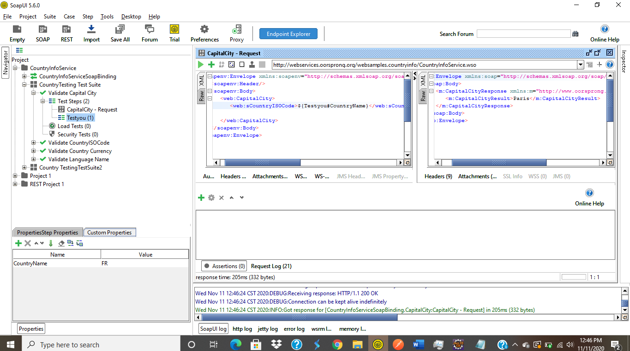

Groovy Script

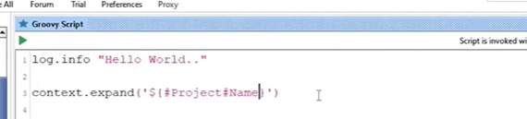

// Project

log.info "SaiYogiRam"

name = context.expand('${#Project#Name}')

log.info ("the Property name is " + name);

//Test Suite

log.info "SaiYogiRam"

name = context.expand('${#TestSuite#Name}')

log.info ("the Property name is " + name);

//Testcase

log.info "SaiYogiRam"

name = context.expand('${#TestCase#Name}')

log.info ("the Property name is " + name);

//Test Step

log.info "SaiYogiRam"

name = context.expand('${Testyou#Name}')

log.info ("the Property name is " + name);

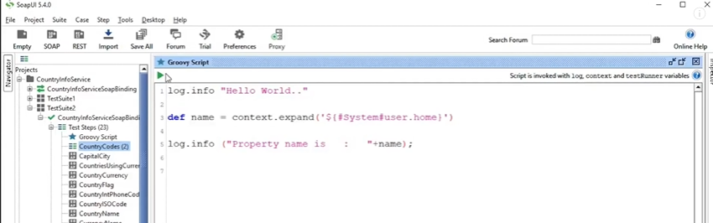

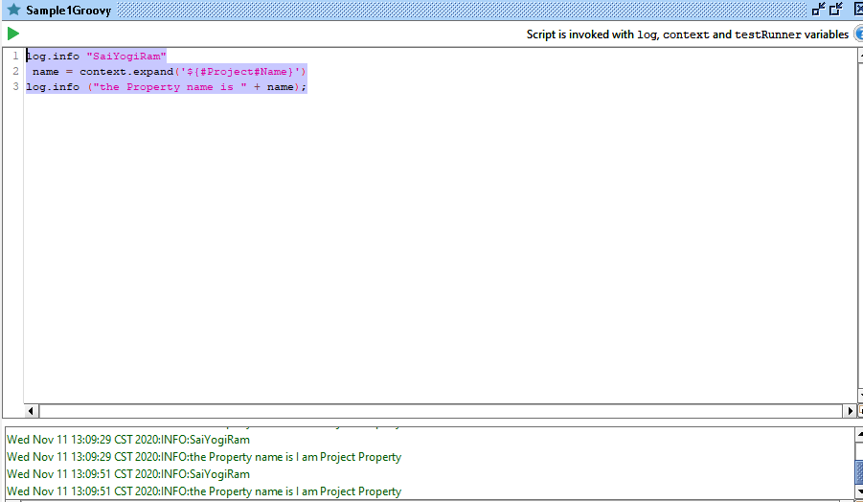

System Property -in Groovy

log.info "SaiYogiRam"

name = context.expand('${#System#user.home}')

log.info ("the Property name is " + name);

Configure – System Propery –

user.name

user.lanugage

**Environment property – ENV**

log.info "SaiYogiRam"

name = context.expand('${#Env#MVN_Home}')

log.info ("the Property name is " + name);

Global Property – Global

File-> Preferences->Global Properites ( add properties and set the value for the property #Name

log.info "SaiYogiRam"

name = context.expand('${#Global#Name}')

log.info ("the Property name is " + name);

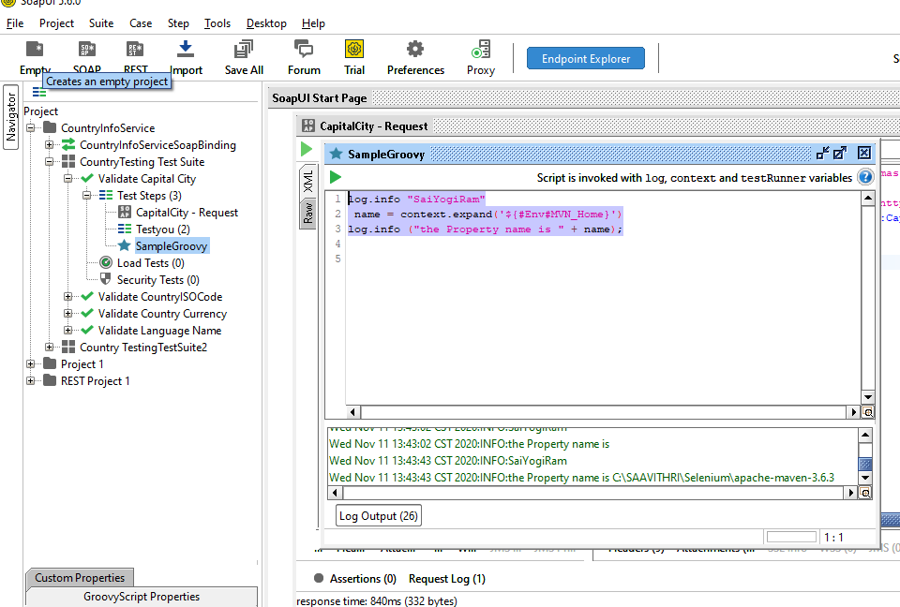

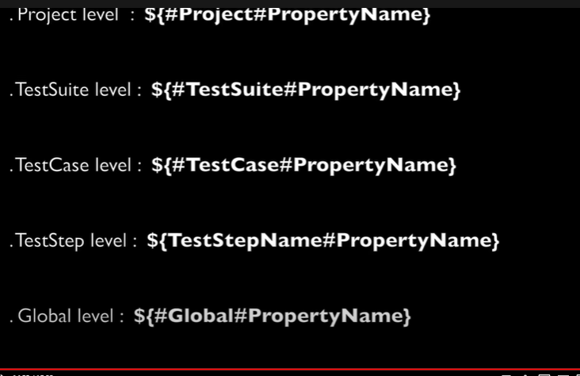

How to Get and Set Property Using Groovy

* Get Property
* Set Property
* Add Property
* Remove Property
* How to loop through all Property

Property could be setup at project level, testSuite level, testcase level

/Property could be set at Project level

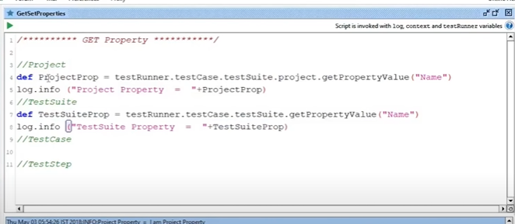

**//Property could be retrieved/GET at Project level, Test Sutite, Test case, test step level**

def projProperty = testRunner.testCase.testSuite.project.getPropertyValue("Name");

log.info("The Project Property is" +projProperty);

**//TestSuite level**

def testSuiteProp = testRunner.testCase.testSuite.getPropertyValue("Name");

log.info("The TestSuite Property is " +testSuiteProp);

**//Testcaselevel**

def testCaseProperty = testRunner.testCase.getPropertyValue("Name");

log.info("The TestCase Property is " + testCaseProperty);

**// Test step level – You have to use the name of the Test step. This is a special case**

def testStepProperty = testRunner.testCase.getTestStepByName("Testyou").getPropertyValue("Name");

log.info("The TestStep Property is" + testStepProperty);

**//Global Property syntax**

def globalProperty = com.eviware.soapui.SoapUI.globalProperties.getPropertyValue("Name")

log.info("The Global Property is " + globalProperty);

//Property could also be set at all levels. We don’t have to use log.info and also we don’t have to store it in any variable. We are only setting values

//Property could be set at Project level

testRunner.testCase.testSuite.project.setPropertyValue("Name","I am ProjectSetValue" );

//Testcase level

testRunner.testCase.testSuite.setPropertyValue("Name", "I am a TestSuiteSetValue");

//Testcaselevel

testRunner.testCase.setPropertyValue("Name", "I am a TestCaseSetValue");

// Test step level

testRunner.testCase.getTestStepByName("Testyou").setPropertyValue("Name", "I am a TestStepValue");

//global Property

com.eviware.soapui.SoapUI.globalProperties.setPropertyValue("Name","Aum Sri SaiRam- I am Global Property");

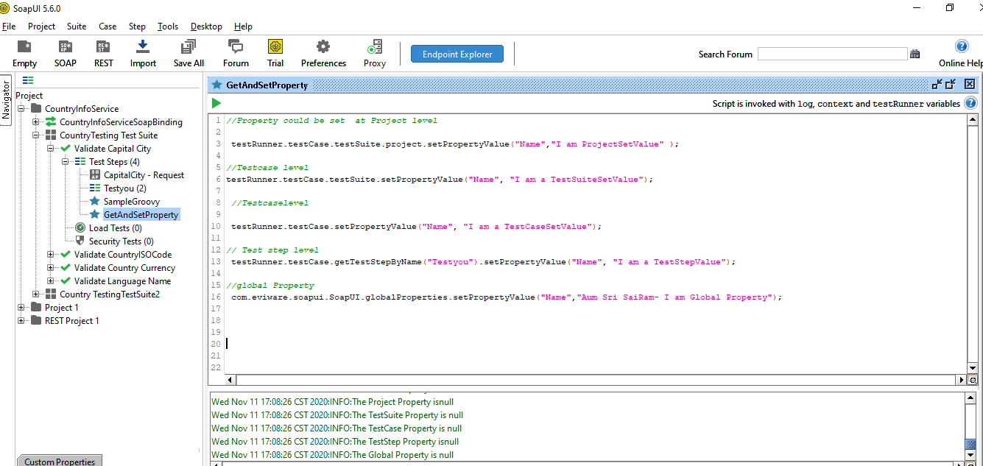

How to Add, Remove Property along with Get and Set Property

/Property could be get and set at Many levels ( Project level, Test Suite level, Test case level)

//set Propery @Project level

testRunner.testCase.testSuite.project.setPropertyValue("Name","I am ProjectSetValue" )

//GetProperty @Project level

log.info(testRunner.testCase.testSuite.project.getPropertyValue("Name"))

// Add property ( only adds the property and not the value. for adding value, you have to use set value

// testRunner.testCase.testSuite.project.addProperty("Address")

//testRunner.testCase.testSuite.project.addProperty("Address2")

//Remove Property

testRunner.testCase.testSuite.project.removeProperty("Address2")

//TestSutite level

//set property @ Test Suite level

testRunner.testCase.testSuite.setPropertyValue("Name", "I am a TestSuiteSetValue");

//get property @ Test Suite level

log.info(testRunner.testCase.testSuite.getPropertyValue("Name"));

//Testcaselevel

//set Property @ Test case level

testRunner.testCase.setPropertyValue("Name", "I am a TestCaseSetValue");

//get Proporty @ Test case level

log.info(testRunner.testCase.getPropertyValue("Name"));

// Test step level

testRunner.testCase.getTestStepByName("Testyou").setPropertyValue("Name", "I am a TestStepValue");

log.info( testRunner.testCase.getTestStepByName("Testyou").getPropertyValue("Name"));

//global Property

com.eviware.soapui.SoapUI.globalProperties.setPropertyValue("Name","Aum Sri SaiRam- I am Global Property");

//log.info(com.eviware.soaui.SoapUI.globalProperties.getPropertyValue("Name"));

Loop throught

// loop through all the values

testRunner.testCase.properties.each

{

key,value ->

log.info(testRunner.testCase.getPropertyValue(key))

}

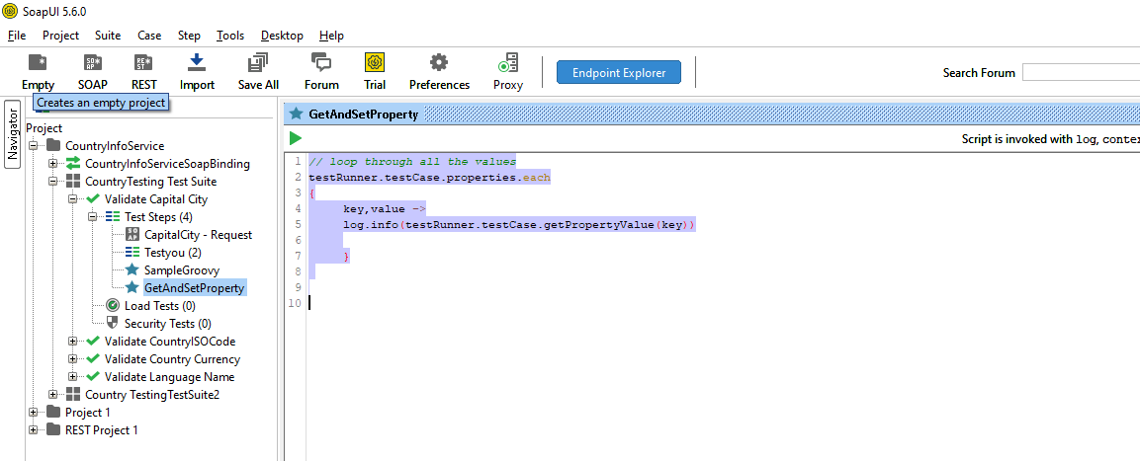

ue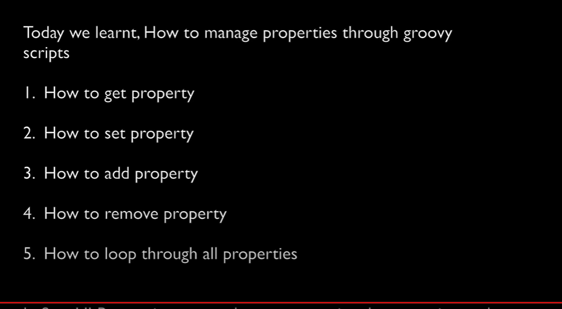

Property Transfer – It is done between two requests. The response of the first request would feed in as request for the other request. This is done using Property Transfer

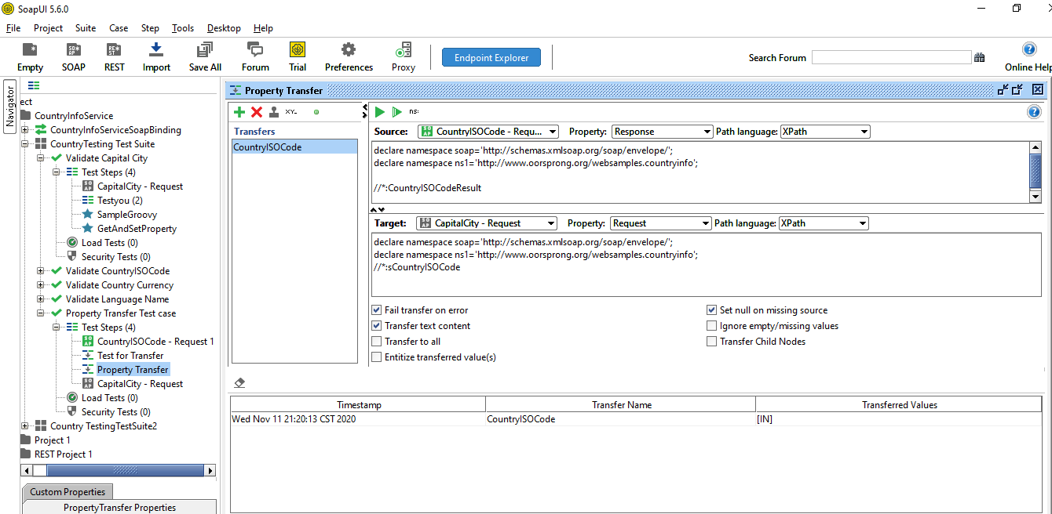

You can also parameterize the parent test case for the property transfer

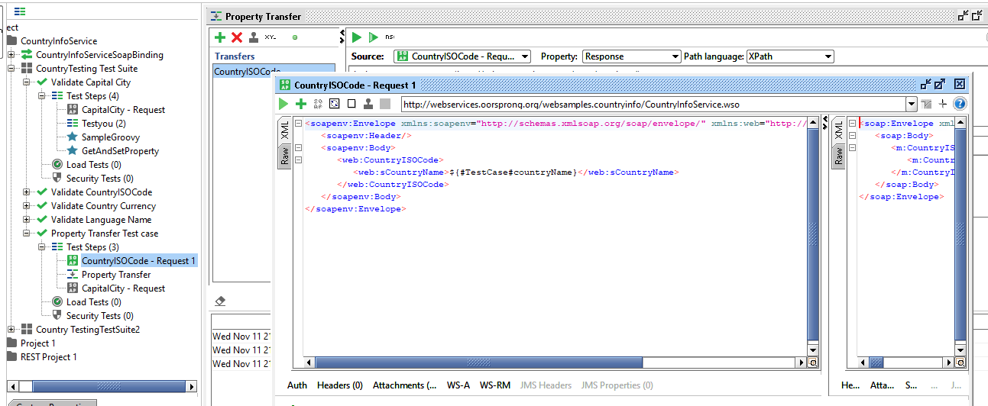

About Groovy

What is Groovy?

Apache Groovy is a Java-syntax-compatible object-oriented programming language for the Java platform. It is both a static and dynamic language with features similar to those of Python, Ruby, and Smalltalk

How to add Groovy to Soap UI?

Add a Test case and right click to add “Groovy Script”

Follows same notations like Java

Follows same comments format like Java

*Log.info*

*testRunner*

*context*

*log.info testRunner.metaClass.methods*.name.unique().sort()*